1. Write a program which accepts a sequence of comma-separated numbers from console and generate a list.

**Solution:**

Code:

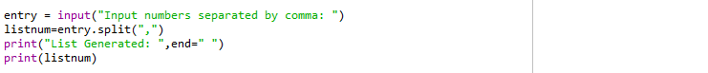

Input & Result



1. Create the below pattern using nested for loop in Python.

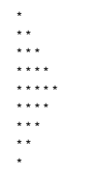

**Solution:**

Code:

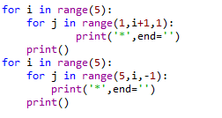

Input & Result

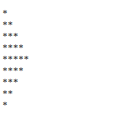

1. Write a Python program to reverse a word after accepting the input from the user.

**Solution:**

Code:

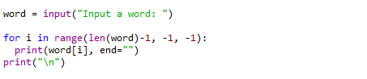

Input & Result



1. Write a Python Program to print the given string in the format specified in the sample

output.

WE, THE PEOPLE OF INDIA, having solemnly resolved to constitute India into a SOVEREIGN,

SOCIALIST, SECULAR, DEMOCRATIC REPUBLIC and to secure to all its citizens

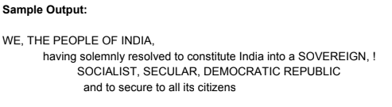

**Solution:**

Code:



Input & Result

